DIGITAL LOGIC DESIGN LAB

REPORT

ECE 1003 L 21-22

WIN 2022-2023.

Name: SWARNLATA

EXPERIMENT -2

**HALF ADDER**

**OBJECTIVE:**Verification of half adder

**THEORY:**half adder is a combinational logic circuit

**BLOCK DIAGRAM:**

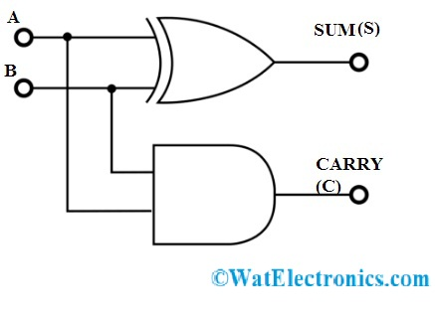

**IMPLEMENTATION AND OUTPUT:**

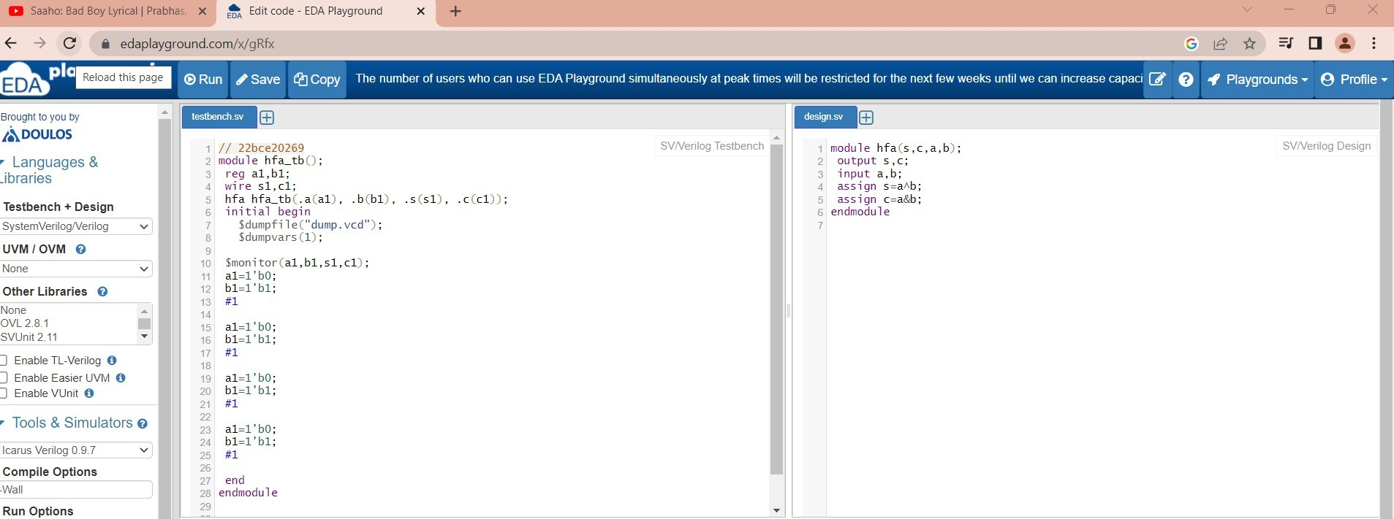

**WAVE FORM:**

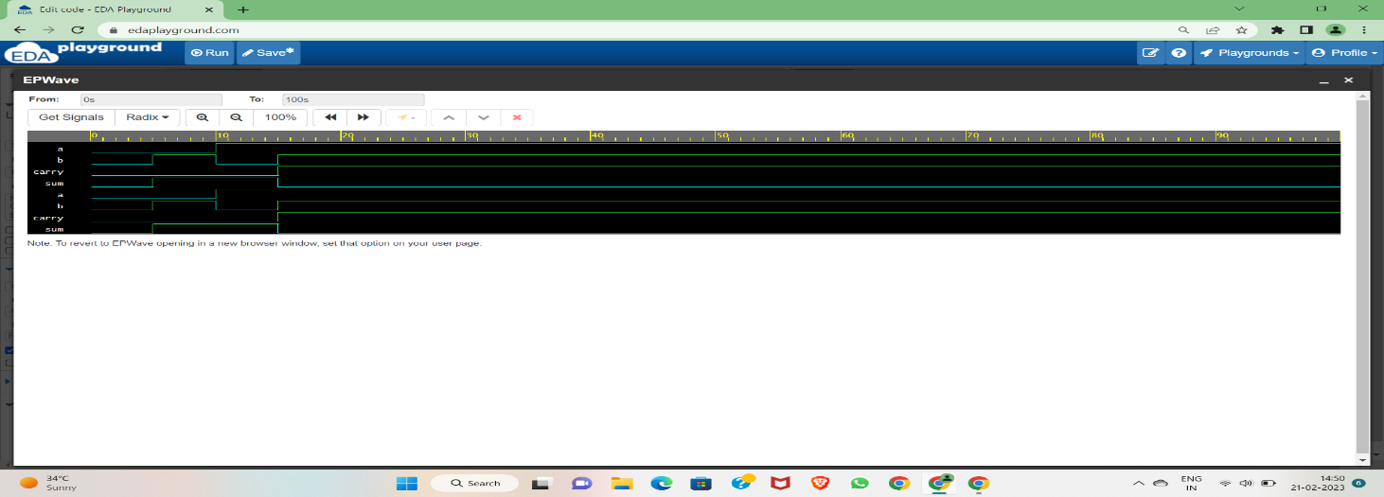

**OBSERVATION:**

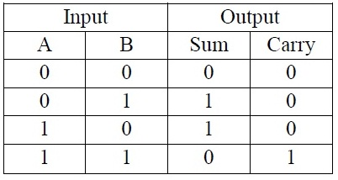

**HALF SUBTRACTOR**

**OBJECTIVE:**Verification of half subtractor

**THEORY:**Half subtractor is a combinational logic gate

**BLOCK DIAGRAM:**

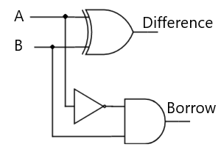

**IMPLEMENTATION AND OUTPUT:**

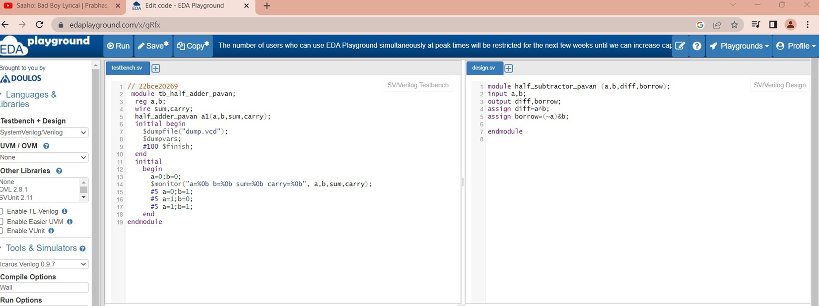

**WAVE FORM:**

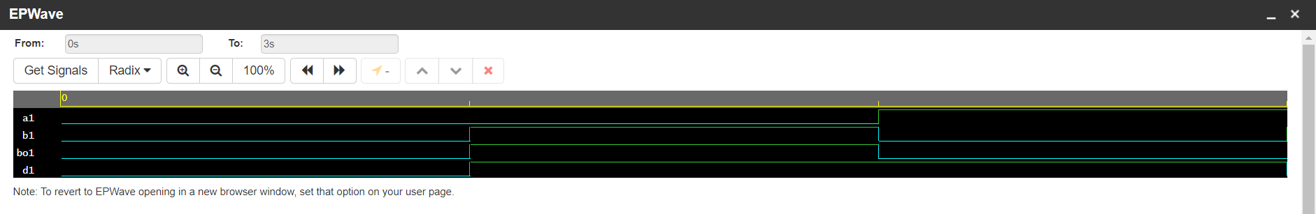

**OBSERVATION:**

